**Steps to Uploading Your Code to GitHub**

Step 1

Create a New Repository in GitHub.com  
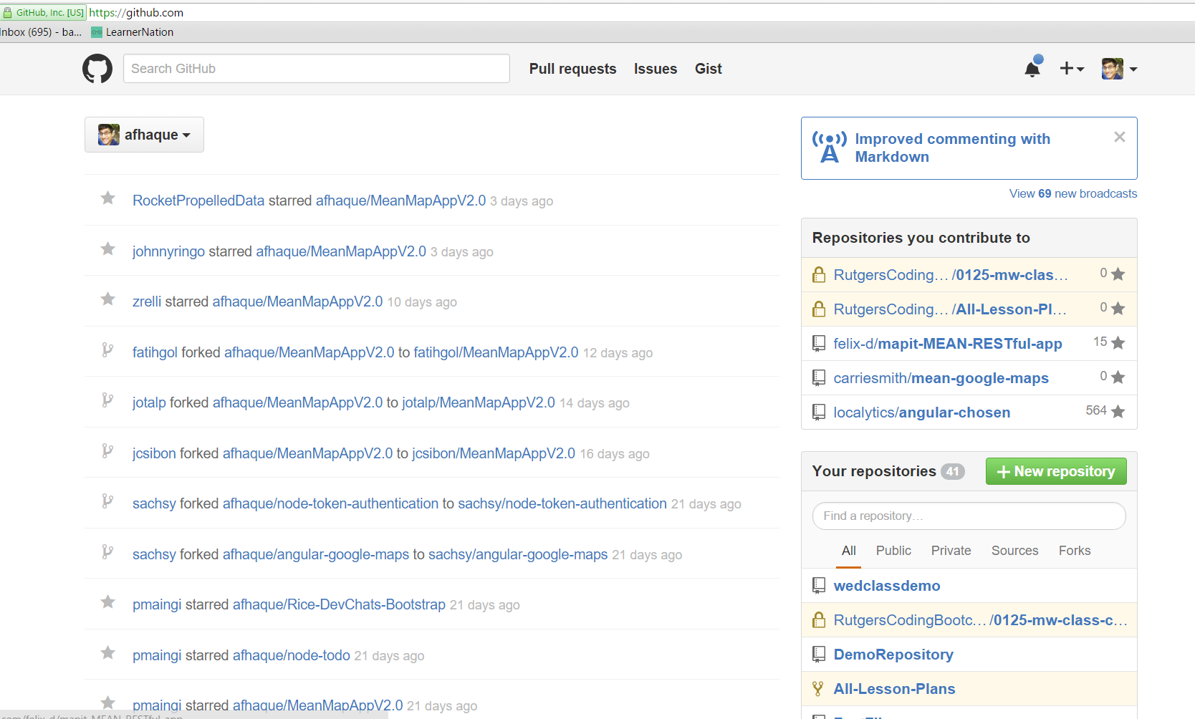

Step 2

Give the Repository a Name, set it to Public, and check “Initialize this repository with a README.”

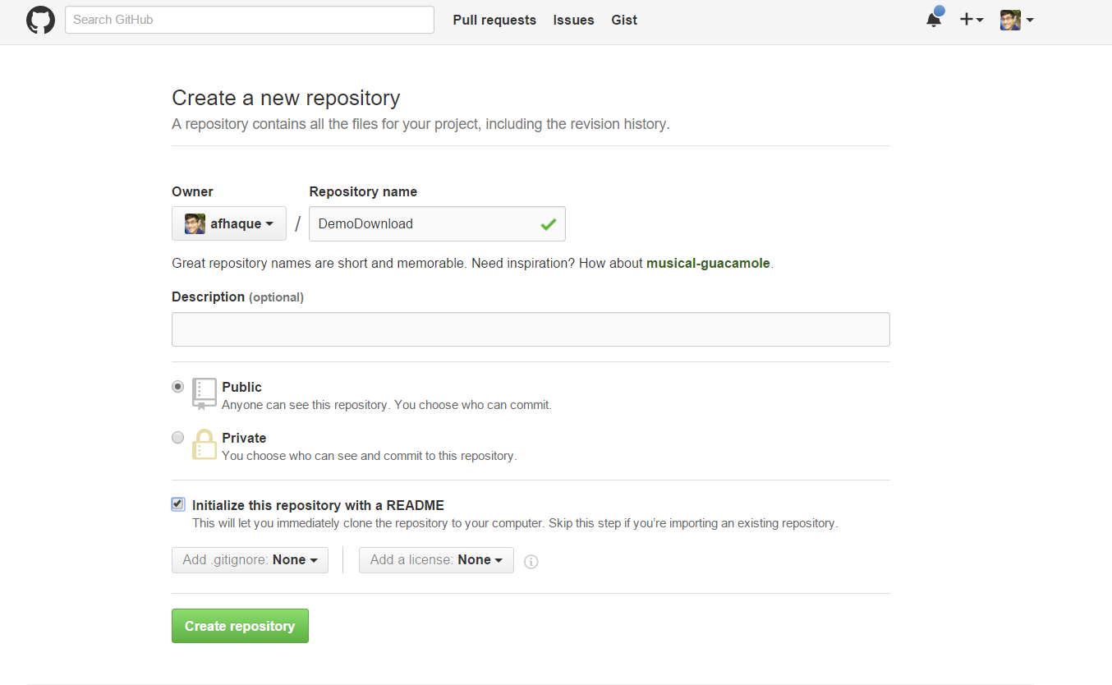

Step 3

Copy the link associated with your new repository from GitHub.

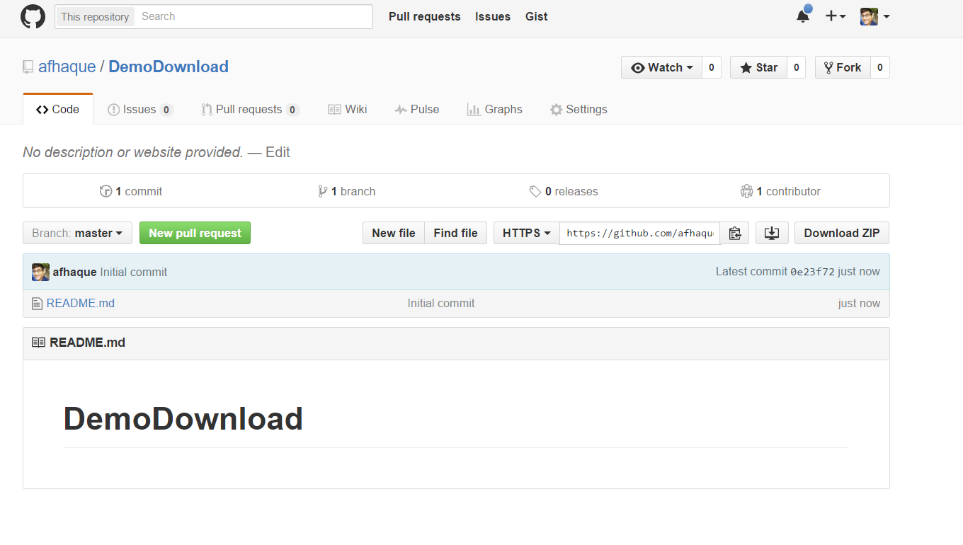

Step 4

Open the Bash (or Terminal) window.

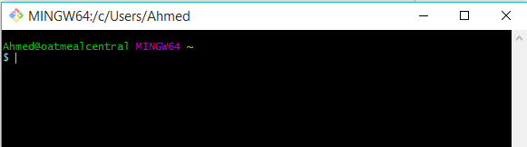

Step 5

Using Console, navigate into a folder where you’d like to download your code.

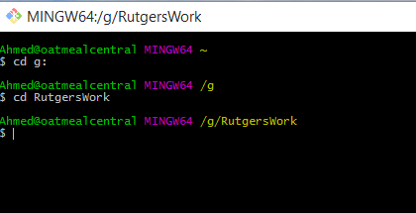

So in my case, I’m navigating into a folder called RutgersWork in my g: Drive. In your case, it can be anywhere on your computer that you want to download code.

Step 6

Next, in console, type the command *git clone _________* and paste the link to your GitHub repository in that blank space. Your screen should look something like mine.

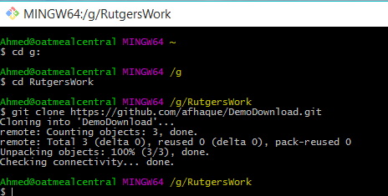

Step 7

Now if you navigate to that folder using file explorer, you will see a new folder with the same name as your repository has been downloaded.

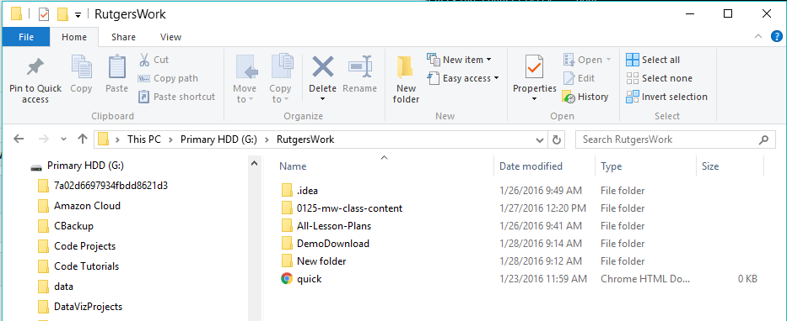

Go into that folder and you will see that it currently has a README file. This folder is now linked to Git.

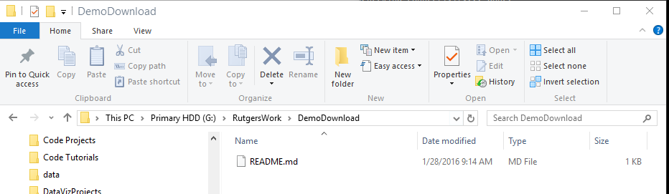

Step 8

Next create a new HTML file (or use an old HTML file). Save that file inside of your local repository folder.

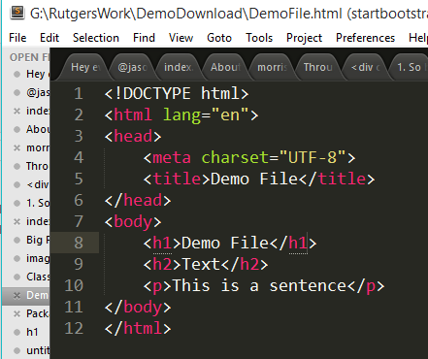

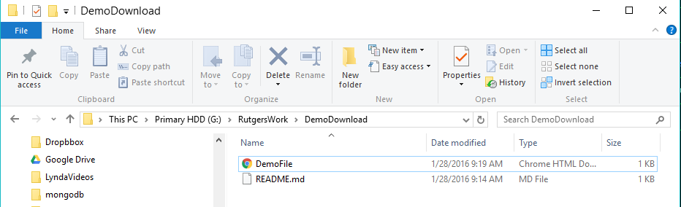

Step 8

In console, navigate into the folder associated with your code using the cd command.



Step 9

Next, type the command *git add –A*. This will tell git to notice the addition of the new html file. If this command worked you shouldn’t see anything happen.

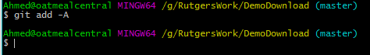

Step 10

Type the command *git commit –m “_____”* and place a comment in the quotes. This will save your changes locally.

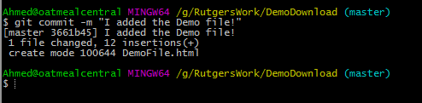

Step 11

Type the final command *git push*. Enter your GitHub username and password if asked.

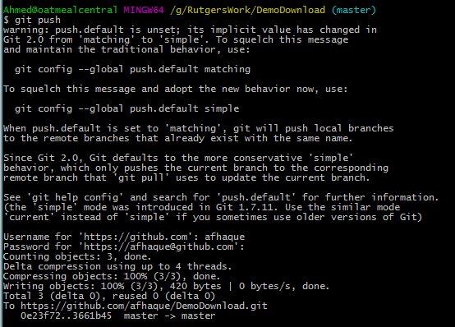

Step 12

Go back to the GitHub repository and you should see the file having been inserted!

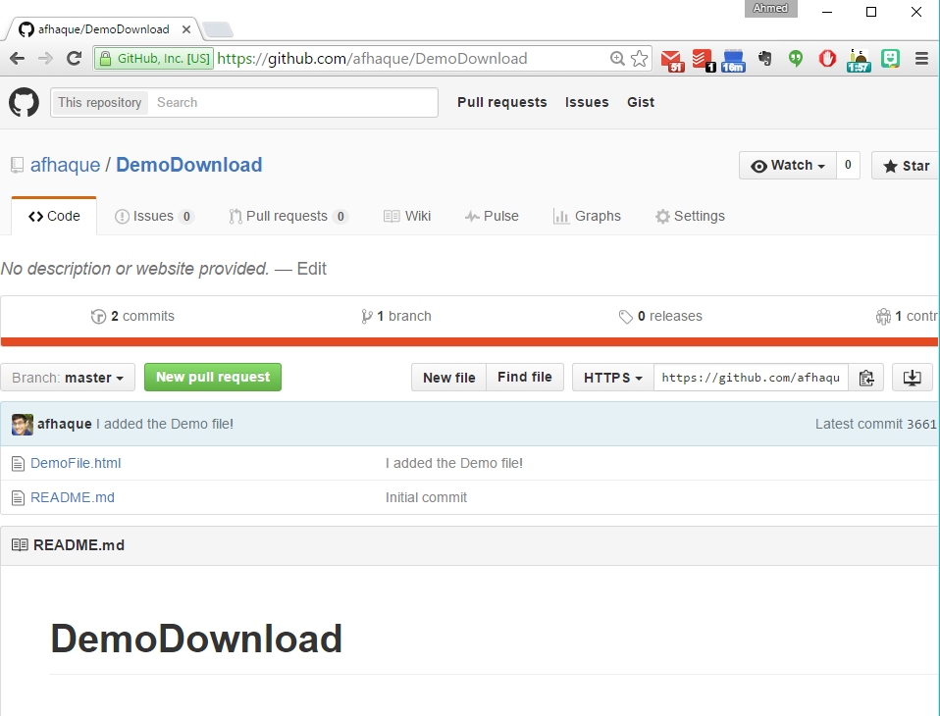

SUCCESS!!!!